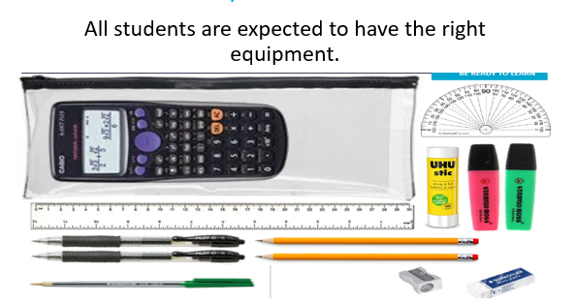

Students may already have some of the equipment needed but will need to have all of the above with them in school from September.

We understand that if your child does not currently have a scientific calculator, there will be a larger cost than you may have been expecting. With this in mind we have sourced the cheapest prices for the whole pencil case and will be able to sell this to you for £9 from the school reception.

