**Science Challenge!**

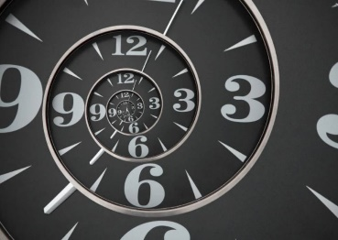**Measuring Time**

**Bonus Challenge**

Design a water/sand clock that measures thirty seconds. You can also design a time measuring device of your own. Draw your plan and discuss with your family. Make a list of materials you would need to make the clock.

**History of Clocks**

How did we measure time over the ages? Draw a timeline for the history of clocks. Pick at least 6 dates to investigate eg. 742 BC.

**What is Time?**

1. List at least five countries that have a New   
   Year other than 1st January.
2. Write down at least three ways that time is measured.
3. Some people say that sometimes time stands still. Is it possible to pause/stop time?