UNIFORM POLICY

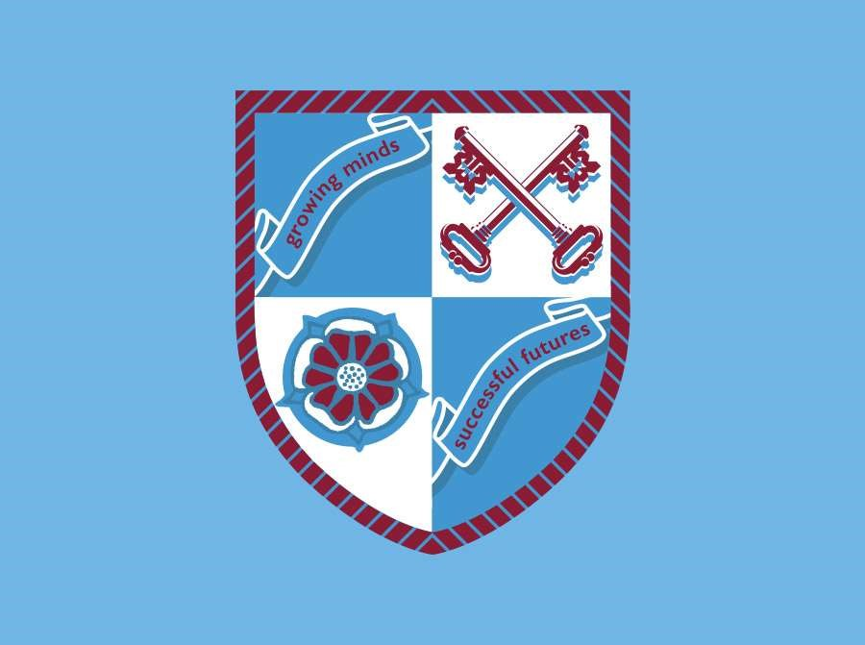

Reviewed by: | Assistant Headteacher | Date: 12 October 2021
Approved by: | Full Governing Body | Date: 23 November 2021
Next review due by: | November 2024

Warblington School is a UNICEF Rights Respecting School. By reflecting on the United Nations Convention on the rights of the child and placing it at the heart of everything we do, we believe that our community is working together to enable our students to a take an active role in developing their place in society both now and as adults of the future (Articles 28 & 29).

Rationale

Students are required to wear uniform because :

- It makes them feel that they belong
- It removes pressures for fashionable and expensive dress from students and parents
- It is the easiest way of identifying sensible and practical clothing, suitable for School Life
- Wearing appropriate uniform is part of establishing Warblington School as a formal learning environment

Aims

All School Policies support the Whole School Aims, in particular this policy supports:

- To accept responsibility for ourselves and others
- To be confident and independent

All students at Warblington School are expected to wear the correct school uniform. Parents have expressed their support for distinctive clothing for Warblington students. Considerable effort is made to maintain standards of dress.

It is a strongly held view of the Governing Body that the school should follow a School Uniform Policy.

Process and Implementation

The Warblington School uniform consists of:
- Clip-on school tie
- Mid-blue shirt, plain, with collar and top button. (not denim, polo/t-shirt or blouse style)
- Black blazer with Warblington School Logo
- (Optional) School V Neck black jumper with blue stripe (no other jumpers are permissible)
- Black trousers embroidered with the Warblington School logo (available from Skoolkit) or tailored black trousers (embroidered badge available from school reception for acceptable trousers) or grey blue SK308 tartan skirt which must be knee length (available from Skoolkit only)
- Sensible, plain black footwear
- Plain socks/tights

All items of clothing should be clearly marked with the name of the student.

PE Kit - Girls and Boys

All students need the same PE kit to take part in PE Lessons.

- Light blue sport polo shirt with the school logo
- Maroon rugby shirt (with white band) – required for boys only
- Gum shield for rugby and hockey
- Blue school PE hooded sweatshirt for girls (optional for boys)
- Two pairs black shorts (one for indoor, one for outdoor use)
- Pair white ankle socks (indoor use)
- Pair of light blue three-quarter length socks (outdoor use)
- Black tracksuit bottoms (optional)
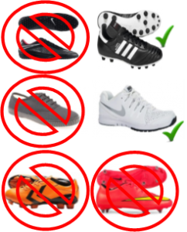
- Plain black leggings with school logo (optional for girls)
- Trainers. Plimsolls and old 2G Astro trainers are not appropriate to use in the Sports Hall and Gymnasium. Trainers can be any colour.
- Studded boots – boys only. Only the style shown in the picture is suitable for our 3G Astro, no blades or metal studs please. This style of boot shown is equally the right boot for grass and for rugby as well.

It is worth reinforcing the fact that the School will also insist upon:

- Black shoes, not trainers
- No denim, or denim look alike to be worn as any item of clothing
- No baseball caps to be worn in school
- No unreasonable haircuts or styles. Hair colour should be natural.
- Body piercings are unacceptable and must be removed.
- The only jewellery allowed is a watch and pair of earrings (small studs, not hoops). Nose studs
- must be removed and replaced with a clear retainer
- Nail varnish / Acrylic nails should not be worn
- False eyelashes are not allowed and they will need to be removed

The School does not accept responsibility for the loss of jewellery or any other item which is brought to School against our advice.

Unacceptable items of jewellery will be confiscated, kept secure in the school safe and returned on Friday at 3.00pm.

