

**BEHAVIOUR POLICY**



|  |  |  |
| --- | --- | --- |
| **Reviewed by:** | Assistant Headteacher |  |
| **Approved by:** | Full Governing Body | **Date:** 2 May 2024 |
| **Next review due by:** | May 2025 |  |

Contents

1. Aims 3

2. Legislation and statutory requirements 3

3. Overview and rationale 4

4. Visions and Values 6

5. Rewards 8

6 Definitions of Misbehaviour 9

7. Bullying 12

8. Roles and Responsibilities 15

9. Sanctions 16

10. Sexual Harrassment and Sexual Violence 17

11. Off-site Behaviour 19

12. Malicious Allegations 19

13. Restraint ………………………………………………………………………………… 20

14. Confiscation………………………………………………………………………………20

15. Student Support …………………………………………………………………………20

16 Safeguarding ……………………………………………………………………………..21

17, Training …………………………………………………………………………………..21

18. Monitoring ………………………………………………………………………………..21

Appendix 1: A – G Ready to Learn Diagram 23

Appendix 2: Mobile phone policy 24

Appendix 3: Detention flow chart 25

Appendix 4: Warblington School Behaviour System 27

Appendix 5: Classroom Ready to Learn Expectations ……………...………………29

Appendix 6: Written statement of behaviour principles

**Introduction**

This policy reflects *Warblington School’s* approach toward developing a trauma informed approach towards behaviour within our community. This policy is for all staff, students, parents / carers, governors, visitors and partner agencies working within the school and provides guidelines and procedures as to how our school supports and responds to behaviour.

Warblington School is committed to the emotional mental health and well-being of its staff, students and parents / carers. We wish to work towards this in all aspects of school life, and to provide an ethos, environment and curriculum that supports the social, emotional and mental health of the whole school community. This policy is written whilst *reflecting on the United Nations Convention on the rights of the child and placing it at the heart of everything we do, we believe that our community is working together to enable our students to a take an active role in developing their place in society both now and as adults of the future (Articles 28 & 29).*

This policy is written alongside our Child Protection, Safeguarding, Attendance and Anti Bullying policies which enable us to put the education of all our students at the forefront of our practice. Following the ethos of Articles 1, 2 and 14, all students are treated equally.

# Aims

This policy aims to:

* Outline how our students are expected to behave
* Provide a consistent approach to behaviour management

# Legislation and statutory requirements

This policy is based on advice from the Department for Education (DfE) on:

* [Behaviour in Schools](https://assets.publishing.service.gov.uk/media/65ce3721e1bdec001a3221fe/Behaviour_in_schools_-_advice_for_headteachers_and_school_staff_Feb_2024.pdf) 2024
* [School Suspensions and Permenant Exclusions](https://www.gov.uk/government/publications/school-exclusion) 2023
* [Behaviour and discipline in schools](https://www.gov.uk/government/publications/behaviour-and-discipline-in-schools)
* [Searching, screening and confiscation at school](https://www.gov.uk/government/publications/searching-screening-and-confiscation)
* [The Equality Act 2010](https://www.gov.uk/government/publications/equality-act-2010-advice-for-schools)
* [Keeping Children Safe in Education](https://www.gov.uk/government/publications/keeping-children-safe-in-education--2)
* [Use of reasonable force in schools](https://www.gov.uk/government/publications/use-of-reasonable-force-in-schools)
* [Supporting pupils with medical conditions at school](https://www.gov.uk/government/publications/supporting-pupils-at-school-with-medical-conditions--3)

It is also based on the [special educational needs and disability (SEND) code of practice](https://www.gov.uk/government/publications/send-code-of-practice-0-to-25).

In addition, this policy is based on:

* Section 175 of the [Education Act 2002](http://www.legislation.gov.uk/ukpga/2002/32/section/175), which outlines a school’s duty to safeguard and promote the welfare of its pupils
* Sections 88-94 of the [Education and Inspections Act 2006](http://www.legislation.gov.uk/ukpga/2006/40/section/88), which require schools to regulate pupils behaviour and publish a behaviour policy and written statement of behaviour principles, and give schools the authority to confiscate pupils’ property

1. **Overview and Rationale**

As a community we have high expectations of behaviour and achievement for every member. This policy aims to ensure consistency in the way all staff, students, parents and carers promote behaviour for learning in the classroom and throughout the school. It is based on clear values; mutual respect, fairness and inclusion. It promotes building positive relationships and self-regulation, respect for others and the importance of actively listening to all members of the school community. It is relevant to every member of the school community and is inclusive of existing Anti- Bullying, Attendance, Equality, Exclusions and Staff Conduct policies. As per the DfE Guidance, [Behaviour in Schools 2024](https://assets.publishing.service.gov.uk/media/65ce3721e1bdec001a3221fe/Behaviour_in_schools_-_advice_for_headteachers_and_school_staff_Feb_2024.pdf), this policy applies to student behaviours throughout the journey to and from school, whenever wearing school uniform and identifiable as students of the school, and when off site on school trips and events. Furthermore, it applies to behaviours at any time, whether in school or not, that could affect the school’s reputation or orderly running, or pose a risk to the wellbeing of other students or members of the public.

Behaviour for learning needs to be taught, modelled, reinforced and reviewed.

Behaviour for learning is, as it suggests, behaviour that allows for and encourages learning to take place. Good behaviour in our school should be modelled, rewarded and facilitated by excellent classroom practice which recognises individual need. Good behaviour is fundamental to success in the classroom; success for both students and teachers. Good behaviour most often results from a well -planned and imaginatively delivered curriculum that inspires students to actively engage and learn, ask questions, debate, enquire and challenge themselves. Students learn best in an ordered and positive environment. This can be achieved when expectations of learning and behaviour are clear and rewards and sanctions are followed through and applied fairly in relation to individual need and capacity. The self-esteem and engagement in learning for all students is nurtured by praise, reward and celebration. This policy is based on recognition of the rights and responsibilities of all members of the school community and the importance for all staff of enabling students to respond and conform to clear and consistent classroom routines and expectation. This is interwoven with a culture that both celebrates success and recognises and rectifies mistakes made.

Adults are responsible for implementing the school’s classroom routines, objectives and strategies for behaviour for learning, as they do for class work. In successful lessons the principles of ready to learn expectations are clearly modelled by everyone in the room.

With this in mind, Warblington School expects:-

* All members of the community to show respect and courtesy towards each other and towards our wider community.
* Every adult within the community will be good at managing and improving student’s behaviour following the guidance of this policy.
* Our parents/carers to encourage their children to show respect and support the schools’ authority to discipline its students.
* The Headteacher to help create a culture of respect across the school by supporting the staff’s authority to discipline students following the ready to learn strategies shown in Appendix 1, ensuring that this happens consistently and fairly across the school.
* The governing body and headteacher to ensure that there are clear and robust procedures to deal with allegations against others in the school community (students, teachers and other school staff) quickly, fairly and consistently in a way that protects the victim and at the same time supports the person who is subject of the allegation.

The behaviour policy also links to the following school policies:

* The Safeguarding Policy (Hampshire policy based on Keeping Children Safe in Education (KCSiE) 2024).
* The Child Protection Policy (Hampshire policy based on Keeping Children Safe in Education (KCSiE) 2024).
* SEN Policy
* Attendance Poliy
* Uniform Policy
* Code of Conduct
* IT Policy

**4 Our Values and Vision**

* Safeguarding and promoting the welfare of children is a priority in our school. We provide a safe and stimulating environment, where students learning and well-being is supported by high quality teaching and pastoral care.
* Our school is characterised by our distinctive ethos of inclusion, achievement, learning together, mutual respect and enjoyment. We are proud of our reputation for high standards in academic work, personal achievement and conduct.
* We recognise young people have many abilities, talents and personalities and learn in many different ways, and are committed to enabling all of our students to achieve their full academic and personal potential. We aspire to enable all students to make the best possible progress regardless of previous achievement or additional learning needs.
* Warblington School is committed to developing resilient, adaptable and resourceful learners. We aim to develop ability, raise expectations and provide the support necessary for life-long success by offering a wide range of enriching experiences both in and beyond the classroom.
* We have a broad, challenging and inclusive curriculum shaped according to the key knowledge, skills and competencies students need to know, understand and do in order to thrive for the rest of their lives. Underpinning this is our value of high quality, on-going professional learning opportunities for all colleagues.
* Students will understand their role and responsibilities in a dynamic, diverse and multi-cultural society: they will be equipped with the skills necessary to thrive in the 21st Century world.
* Putting relationships first. This requires a school ethos that promotes strong relationships between staff, students and their parents/carers. It also relies on creating a positive school culture and climate that fosters connection, inclusion, respect and value for all members of the school community. Everything we do is based on building positive attachments (mutually respectful relationships) with our students.
* Maintaining clear boundaries and expectations around behaviour. Changing how we respond to behaviour does not mean having no expectations, routines or structure. In order to help students feel safe, their educational environment needs to be high in both nurture and structure. Students need predictable, consistent routines, expectations and responses to behaviour. These must be in place and modelled appropriately, within the context of a safe and caring school environment.
* Being ‘fair’ is not about each student getting the same (equality) but about everyone getting what they need (equity).

**Restorative justice.**

* Restorative approaches enable those who have been harmed to convey the impact of the harm to those responsible and for those responsible to acknowledge this impact and take steps to put it right.
* As we take a non-judgmental, curious and empathic attitude towards behaviour, we encourage all adults in school to respond in a way that focuses on the feelings and emotions that might drive certain behaviour, rather than the behaviour itself. Students with behavioural difficulties need to be regarded as vulnerable rather than troublesome, and we all have a duty to explore this vulnerability and provide appropriate support. We acknowledge that behaviour is a form of communication of an emotional need.
* Encouraging parental engagement and involvement is crucial when addressing and planning support for student’s social, emotional and mental health (SEMH) needs.
* We look at each event in context and are committed to explaining our practices to students, offer them reasons to work with us and encourage reflective dialogue and self-regulation.
* We treat students as individuals, ensure that the curriculum is appropriate for each student and that teaching styles are apt, and we use praise and rewards as our main tool. There is a lot of encouragement in our school.

When working with young people, we encourage colleagues to:

1. Take care of themselves
2. Know and apply specific advice contained within a studen’s profile

2. Listen to and talk with students

3. Be patient with the student's progress and with themselves

4. Model and teach appropriate social behaviours

5. Be consistent, predictable and repetitive

6. Interact with these students based on emotional age

7. Try to understand that the behaviours resorting to punishment may reinforce the negative responses

8. Nurture all students

# 5 Rewards

Warblington School uses the A – J Expectations to monitor the behaviour principles of the school The school uses ClassCharts (Arbor) to record both house points and behaviour levels. Staff are encouraged to positively reward good behaviour and effort at every opportunity. ClassCharts (Arbor) records the figures, which are used within assemblies to further celebrate success and also as part of our annual presentation events.

* **A**lways follow adult instructions
* **B**e polite, kind and respectful at all times
* **C**omplete all work with maximum effort
* **D**o wear the correct school uniform at all times
* **E**nsure that you bring the correct equipment/ books/ materials to all lessons
* **F**ollow mobile phone procedures
* **G**et to all lessons on time
* **H**omework must be completed and handed in on time
* **I**nspire others
* **J**ewellery must follow the school rules

Alongside the use of house points for each of the A – J expectations, positive behaviour can also be rewarded through:

* Verbal Praise around school and within assembly
* ClassCharts (Arbor) announcements to students
* ClassCharts (Arbor) announcement, emails or phone calls home to parents/carers
* Special responsibilities/privileges – e.g. hot chocolate Friday, queue pass for lunches etc

# 

# 6 Definitions

# At Warblington School misbehaviour is defined as:

* Disruption in lessons, in corridors between lessons, and at break and lunchtimes (guided by the ready to learn procedures) (Appendix 1)
* Non-completion of classwork or homework
* Poor attitude
* Incorrect uniform
* Missing items of equipment needed for the lesson, including PE kit and materials for lessons.

The recording of misbehaviour within lessons is via the allocation of “yellow” levels on ClassCharts (Arbor) following the A – J expectations. Recording of misbehaviour outside of lessons is via the “undesirable” level on Classcharts with a brief explanation of actions.

Using the Hampshire Guidance based on [School Suspensions and School Exclusions (Updated 2023)](https://www.gov.uk/government/publications/school-exclusion) Schools (Feb 2022), at Warblington School **serious misbehaviour** is defined as:

1. Persistent disruptive behaviour / disruptive general behaviour

* Challenging behaviour
* Disobedience
* Persistent violation of school rules

1. Physical assault against a student

* Fighting
* Violent behaviour
* Wounding
* Obstruction and jostling

1. Physical assault against an adult

* Violent behaviour
* Wounding
* Obstruction and jostling

1. Verbal abuse / threatening behaviour against another (Child or adult)

* Threatening violence
* Aggressive behaviour
* Swearing
* Homophobic abuse and harassment
* Verbal intimidation
* Carrying an offensive weapon

1. Bullying (See below for bullying definitions)

* Verbal
* Physical
* Discriminative bullying (racist, sexist (including sexual orientation),homophobic)

1. Racist abuse

* Racist taunting and harassment
* Derogatory racist statements
* Racist bullying
* Racist graffiti
* Swearing that can be attributed to racist characteristics

1. Abuse against sexual orientation and gender identity

* Verbal / threatened / taunting / mimicking / mocking / harassment abuse
* Written abuse / derogatory comments and /or publishing on social media
* Physical abuse / contact

1. Abuse relating to disability (including those which are ‘hidden’)

* Verbal / threatened / taunting / mimicking / mocking / harassment abuse
* Written abuse / derogatory comments and /or publishing on social media
* Physical abuse / contact

1. Sexual misconduct

* Sexual abuse
* Sexual assault
* Sexual harassment
* Lewd behaviour
* Upskirting
* Sexual bullying
* Sexual graffiti

1. Drug and alcohol related

* Smoking (including vaping and possession of related paraphernalia)
* Alcohol abuse
* Substance abuse
* Possession of illegal drugs (also reported to police)
* Inappropriate use of prescribed drugs (also reported to police)
* Drug dealing - including selling Vapes (also reported to police)

11. Damage

* Damage to school or personal property belonging to any member of the school community
* Vandalism
* Arson
* Graffiti

12. Theft

* Stealing school property
* Stealing from local shops / on a school outing
* Stealing personal property (from a student or adult)
* Selling and dealing in stolen property

1. Possession of, or use or threat of use of an offensive weapon or prohibited item

* Deliberately brining an offensive weapon to school in order to cause harm
* Threatening others with an offensive weapon
* Using an offensive weapon or prohibited item to harm someone
* Possession of fireworks
* Possession of pornography
* Possession of any article a staff member reasonably suspects has been, or is likely to be, used to commit an offence or to cause personal injury to, or damage to the property of, any person (including the student)

1. Inappropriate use of social media or online technology

* Filming staff or students without their permission
* Circulating / distributing filmed footage / images to cause deliberate offence
* Creating web pages or social media accounts relating to staff and / or students
* Commenting on web pages or social media accounts relating to staff and/or students
* Hacking into school IT systems / deliberately misusing systems to cause offence or disruption

1. Wilful and repeated transgression of protected measure in place to protect public health

* Refusal to follow health and safety rules
* Refusal to follow one-way system
* Refusal to follow social distancing rules (refusing to wear a mask / hand sanitise/ misuse of antibacterial products)

# Bullying (Child on Child Abuse)

**Bullying** is a repetitive, intentional abuse of power by an individual or group over another individual or group through the use of greater physical or mental strength, which leads to the victim feeling intimidated and unhappy. Any situation in which a victim feels threatened by the abuse of such power will be treated as a bullying / child on child incident.

Bullying is, therefore:

* Deliberately hurtful
* Repeated, often over a period of time
* Difficult to defend against

1. Bullying can include:

| TYPE OF BULLYING | DEFINITION |
| --- | --- |
| Emotional | Being unfriendly, excluding, tormenting, verbal abuse either in person or online |
| Physical | Hitting, kicking, pushing, taking another’s belongings, any use of violence |
| Prejudice-based and discriminatory, including:   * Racial * Faith-based * Gendered (sexist) * Homophobic/bi-phobic * Transphobic * Disability-based | Taunts, gestures, graffiti or physical abuse focused on a particular characteristic (e.g. gender, race, sexuality) |
| Sexual | Explicit sexual remarks, display of sexual material, sexual gestures, unwanted physical attention, comments about sexual reputation or performance, or inappropriate touching |
| Direct or indirect verbal | Name-calling, sarcasm, spreading rumours, teasing |
| Cyber-bullying | Bullying that takes place online, such as through social networking sites, messaging apps or gaming sites |

**Reporting incidents of bullying**

All stakeholders in the Warblington School community are encouraged to report any child on child abuse at the earliest opportunity.

Students should alert any member of staff as soon as the bullying/child on child abuse is carried out. If students do not feel they can do this in person, all classroom based staff can be contacted using the students ClassCharts (Arbor) account. All students are encouraged to be aware of their peers and if they are worried someone may be a victim of bullying, they should also report this in the same ways above.

Parents are encouraged to report if they feel their child is a victim of bullying / child on child abuse. This can be done by an email to the school at [admin@warblingtonschool.co.uk](mailto:admin@warblingtonschool.co.uk) or to the specific tutor or year leader via email or ClassCharts. In general the school email consists of the initial followed by a full stop with the surname of a member of staff e.g. “j.bloggs@warblingtonschool.co.uk” .

Parents and Carers can also report their concerns via a ClassCharts announcement. Concerns can also be reported by phone via the school reception on 02392 475480. and will be forwarded to the tutor / Head of House.

Staff who are concerned about potential bullying or child on child abuse can report this via the safeguarding element of Edukey.

***How the school investigates allegations of bullying***

Statements will be taken from the victim and the aggressor alongside any witnesses of the event. Any social media evidence available will be downloaded and added to the Edukey safeguarding raised by this incident. Once statements have been taken parents and carers are informed of the incident and the level of sanction to be imposed is discussed. Following the statements, the school follows a restorative approach in which a meeting between the victim and aggressor will be arranged as soon as possible after the incident, taking into consideration the victim’s welfare.

***How the school records, analyses and monitors incidents of bullying***

Using our ClassCharts (Arbor) systems we are able to record, analyse and monitor all aspects of bullying within the school. Any incident which involves prejudicial language and/or behaviour is also recorded using a Prejudicial Language and Behaviour form (PLAB) which feeds into our annual report to Hampshire. Behaviour records are shared with the governing body at regular intervals throughout the year.

***How the school supports pupils who have been bullied, and those vulnerable to bullying***

Both the victim, the perpetrator and any others affected by the bullying incident will be offered support by the inclusion team (e.g. tutor/Head of House/health and wellbeing team). Opportunities also exist for additional support to be offered by external agencies working with us when the school feel this is of benefit to the students.

***Whole-school proactive strategies to prevent bullying***

Within our assembly and tutor programme every opportunity is taken to stress to the community the importance of treating others as they wish to be treated. Child on child abuse/ bullying is a reoccurring theme across our weekly enrichment programme and is also dealt with via curriculum areas as applicable e.g. slavery within history.

*How the school trains staff and governors in preventing and handling bullying*

The training of adults within the community takes place in regular meetings and training sessions. All staff are provided with safeguarding training annually, with regular refreshers throughout the year.

# Roles and responsibilities

The governing body

The governing body will also review this behaviour policy in conjunction with the headteacher and monitor the policy’s effectiveness, holding the headteacher to account for its implementation. This review will follow Government guidance [Behaviour and Discipline in Schools](https://assets.publishing.service.gov.uk/media/5a8079b4ed915d74e622eaaa/Behaviour_and_discipline_in_schools_guidance_for_governing_bodies.pdf).

The headteacher

The headteacher is responsible for reviewing this behaviour policy in conjunction with the governing body. The headteacher will also approve this policy.

The headteacher will ensure that the school environment encourages positive behaviour and that staff deal effectively with poor behaviour, and will monitor how staff implement this policy to ensure rewards and sanctions are applied consistently.

Staff

Teaching and support staff are responsible for setting the tone and context for positive behaviour within the classroom.

They will:

* Create and maintain a stimulating environment that encourages students to be engaged
* Display the schools expectations of behaviour A – J’s
* Develop a positive relationship with students, which should include:
  + Greeting students in the morning/at the start of lessons
  + Establishing clear routines
  + Communicating expectations of behaviour in ways other than verbally
  + Highlighting and promoting good behaviour
  + Concluding the day positively and starting the next day afresh
  + Having a plan for dealing with low-level disruption following the ready to learn system
  + Using positive reinforcement with a personalised approach to the specific behavioural needs of particular students
  + Recording behaviour incidents on Classcharts (Arbor) and, when necessary, additionally on Safeguarding (Edukey).

The senior leadership team will support staff in responding to behaviour incidents.

Parents

Parents are expected to:

* Support their child in adhering to the schools ready to learn procedures
* Inform the school of any changes in circumstances that may affect their child’s behaviour
* Discuss any behavioural concerns with the class teacher promptly

**9 Sanctions**

The school may use one or more of the following sanctions in response to misbehaviour:

* A verbal warning, followed by the issuing of a yellow card on ClassCharts (Arbor)
* Sending the student to the Reflection Room if a second yellow card on ClassCharts (Arbor) is needed
* Detention at break or lunchtime, or after school (this happens automatically should second yellow be issued)
* Referring the student to a tutor / Head of House / senior member of staff
* Emails, phone calls or letters home to parents/carers
* Agreeing a behaviour contract
* Putting a pupil ‘on report’

In line with our ready to learn policy, we use the lesson in the Reflection Room as a

time for reflection on poor behaviour and the interrupting of learning.

In response to misbehaviour such as truancy and a refusal to hand in mobile phone students will be placed in our Wave room for an extended day. This sanction places the student out of circulation from the rest of the school including break times. Through blended learning, students will be expected to complete the same work as they would in class or an equivalent task. The timing of the wave room is automatically extended by an hour, however students can “earn” back up to thirty minutes if they present themselves on time, hand in their mobile phones and follow the expectaitons of the room.

Students who do not attend a given detention receive an escalated detention as a sanction. After this the student is expected to spend a day in the wave room, immediately followed by the unspent hours’ detention.

Students who receive negative behaviour points will be sanctioned accordingly as their points are accrued. As highlighted in the policy (Section 6), Warblington school treats persistent disruptive behaviour / disruptive general behaviour as a serious misbehaviour. Therefore persistent violation of school rules, challenging behaviour and disobedience will be sanctioned as a serious misbehaviour.

The school may use one or more of the following sanctions in response to serious misbehaviour:

* Day/s in WAVE
* Federation Inclusion (various hours)
* Suspensions
* Expulsions

Zero-tolerance approach to sexual harassment and sexual violence

In line with our Child Protection and Safeguarding policies, the school will ensure that all incidents of sexual harassment and/or violence are met with a suitable response, and never ignored. All these policies are underpinned by the principle that there is a zero-tolerance approach to sexual violence and sexual harassment. It is not an inevitable part of growing up and it cannot be described as ‘banter’, ‘having a laugh’ or ‘boys being boys’.

Students are encouraged to report anything that makes them uncomfortable, no matter how ‘small’ they feel it might be. Children making a report of a sexual violence or sexual harassment will be taken seriously, kept safe and be supported. For further information on this please refer to Annex 6 in the Child Protection Policy and the Safeguarding Policy (page 11).

The school’s response will be:

* Proportionate
* Considered
* Supportive
* Decided on a case-by-case basis

Sanctions for sexual harassment and violence may include:

* Immediate removal to the Reflection or Wave room
* Classcharts incident report
* Contact to parent/carer
* Detention after school
* Fixed Term Exclusion
* Referral to the police

The school has procedures in place to respond to any allegations or concerns regarding a child’s safety or wellbeing. These include clear processes for:

* Responding to a report
* Carrying out risk assessments, where appropriate, to help determine whether to:
  + - Manage the incident internally
    - Refer to early help
    - Refer to children’s social care
    - Report to the police

Please refer to our child protection and safeguarding policies for more information.

1. Off-site behaviour

Sanctions may be applied where a student has misbehaved off-site when representing the school. This means misbehaviour when the student is:

* Taking part in any school-organised or school-related activity (e.g. school trips/fixtures)
* Travelling to or from school
* Wearing school uniform
* In any other way identifiable as a student of our school

Sanctions may also be applied where a student has misbehaved off-site at any time, whether or not the conditions above apply, if the misbehaviour:

* Could have repercussions for the orderly running of the school
* Poses a threat to another student or member of the public
* Could adversely affect the reputation of the school

Sanctions will only be given out on school premises or elsewhere when the student is under the lawful control of the staff member (e.g. on a school-organised trip).

1. Malicious allegations

Where a student makes an allegation against a member of staff and that allegation is shown to have been deliberately invented or malicious, the school will discipline the student in accordance with this policy.

Where a student makes an allegation of sexual violence or sexual harassment against another student and that allegation is shown to have been deliberately invented or malicious, the school will discipline the student in accordance with this policy.

In all cases where an allegation is determined to be unsubstantiated, unfounded, false or malicious, the school (in collaboration with the local authority designated officer, where relevant) will consider whether the student who made the allegation is in need of help, or the allegation may have been a cry for help. If so, a referral to children’s social care may be appropriate.

The school will also consider the pastoral needs of staff and students accused of misconduct.

Please refer to our child protection and safeguarding policy more information on responding to allegations of abuse against staff or other student.

12 Physical restraint

In some extreme circumstances, staff may have to use reasonable force to restrain a student to prevent them:

* Causing disorder
* Hurting themselves or others
* Damaging property

Incidents of physical restraint will follow the school’s Physical Restraint Policy and must:

* **Always be used as a last resort**
* Be applied using the minimum amount of force and for the minimum amount of time possible
* Be used in a way that maintains the safety and dignity of all concerned
* Never be used as a form of punishment
* Be recorded and reported to parents/carers via a telephone call from a member of the senior leadership team

**13 Confiscation**

**Any prohibited items / dangerous items found in pupils’ possession will be confiscated.** These items will not be returned to students.

We will also confiscate any item which is harmful or detrimental to school discipline. These items might be returned to students after discussion with senior leaders and parents/carers, if appropriate. All vapes confiscated are handed to the police for disposal.

Searching and screening students is conducted in line with the DfE’s [latest guidance on searching, screening and confiscation](https://www.gov.uk/government/publications/searching-screening-and-confiscation).

14 Student support

The school recognises its legal duty under the Equality Act 2010 to prevent students with a protected characteristic from being at a disadvantage. Consequently, our approach to challenging behaviour may be differentiated to cater to the needs of the student.

The school’s special educational needs co-ordinator will evaluate a student who exhibits challenging behaviour to determine whether they have any underlying needs that are not currently being met.

Where necessary, support and advice will also be sought from specialist teachers, an educational psychologist, medical practitioners and/or others, to identify or support specific needs.

When acute needs are identified in a student, we will liaise with external agencies and plan support programmes for that child. We will work with parents/carers to create the plan and review it on a regular basis. In these cases a health and safety risk assessment maybe needed.

15 Safeguarding

The school recognises that changes in behaviour may be an indicator that a student is in need of help or protection. We will consider whether a student’s misbehaviour may be linked to them suffering, or being likely to suffer, significant harm. Where this may be the case, we will follow our child protection and safeguarding policies.

# 

# Pupil transition

Transition into Warblington from primary schools is a well-planned and supported process. Year 6 students are invited to spend time across the year at the school, experiencing the systems and behaviour expectations. In the September start, students are introduced to the behaviour systems within the school. Information on safeguarding and behaviour is collated by the school’s SENCO/ Assistant Headteacher.

At year 7, to ensure a smooth transition to the next year, students have transition sessions with their new tutor. To ensure behaviour is continually monitored and the right support is in place, information related to student behaviour issues will be available on ClassCharts (Arbor).

# Training

Behaviour management will continue to form part of continuing professional development.

# 17. Monitoring arrangements

This behaviour policy will be reviewed by the headteacher and the governing body annually. At each review, the policy will be approved by the headteacher.

The written statement of behaviour principles (Appendix ?) will be reviewed and approved by the governing body annually.

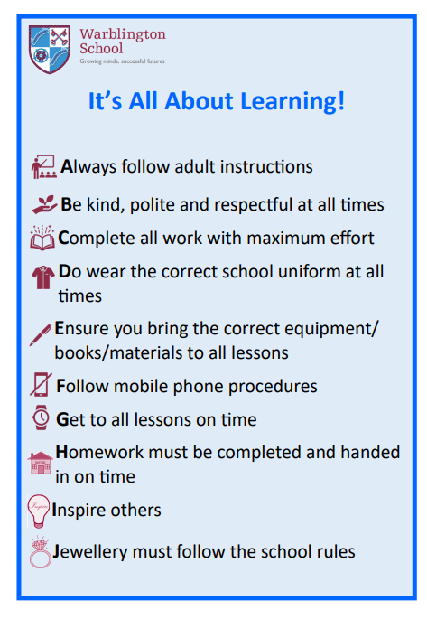**APPENDIX 1**

**Expectation F – Follow the Mobile Phone Policy**

|  |  |  |
| --- | --- | --- |
| Mobile Phone Policy (See it, Hear it, Lose it)  No use of mobiles on school site until 3pm. |  | Student given Level 1 ‘F’ sanction on ClassCharts. Student hands over their phone, **phone taken to Reception and can be collected from Reflection Room** at the end of the day. |
|  |  |
| Student refuses to hand over their phone | Level 2 ‘F’ sanction set on ClassCharts by teacher. Reflection Room staff / Mrs West to monitor and report to Leadership Team on duty to pick up student and collect phone. Taken to reception and can be collected at the end of the day. **Sanction of WAVE next day** |
|  | | |
| Student refuses to hand phone over to SLT/VWT following Level 2 sanction. |  | Student is placed in WAVE for the remainder of the school day and the next day with a restorative Justice discussion with Head of House and completion of work around mobile phone addiction. |
|  | | |
| **Regular Phone Offenders**  (3 times in a half term) |  | **Regular phone offenders will be encouraged to leave phone at home or at reception daily when at parental meeting to write behaviour contract. Arranged by Head of House.** |

“G” late mark awarded for lateness

Level 2 sanction given by class teacher

Student attends 15-minute detention break / lunch /after school.

G mark = 15 minute detention automatically set.

Level 2 - Student leaves lesson and presents themselves in the Reflection Room

(Monitored and logged on ClassCharts/Arbor)

Student attends 30-minute detention after school with a restorative justice discussion with class teacher

Student is unable to do detention (legitimate reasons). Detention sat the next night (date changed on ClassCharts/Arbor by Year Leader)

Student refuses to attend detention

**Detention time upscaled** for next day. (Time doubled) Student highlighted on register for collection by Leadership Team / Year Leader or brought over by class teacher

Student refuses to attend extended detention

Student attends detention with restorative justice discussion with class teacher

Student placed in WAVE with extended day until 4pm

Student does not attend the Reflection Room following   
level 2 set on system

Student is reported to on-call by Reflection Room and a truancy level is issued on ClassCharts.

Student will remain in the reflection room for the **remainder of the lesson and the next lesson**

Student attends 30 minutes detention after school with a Restorative Justice discussion with class teacher

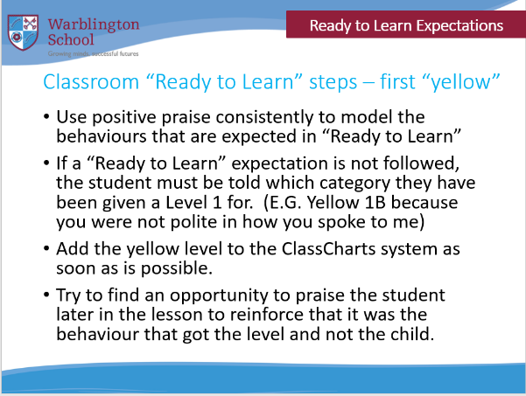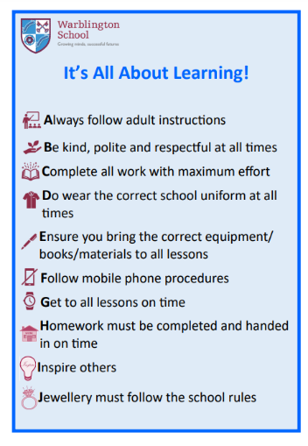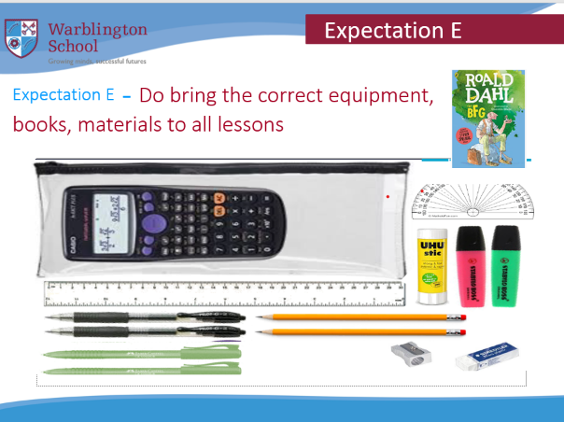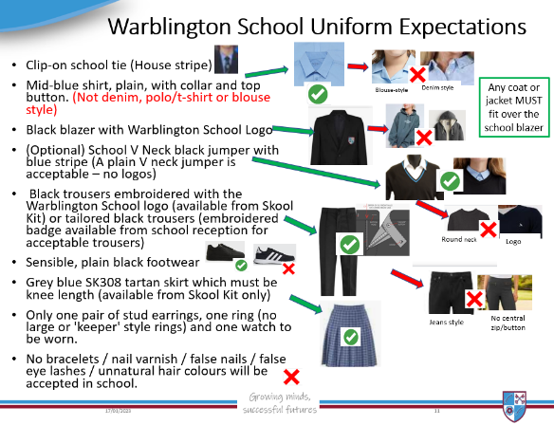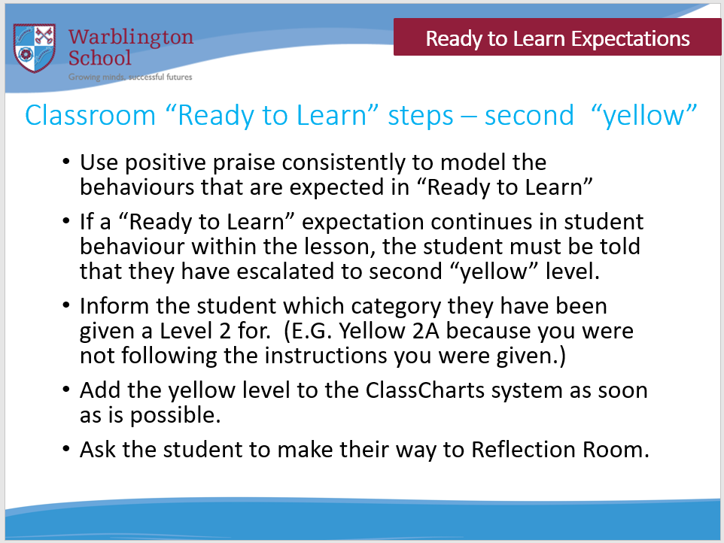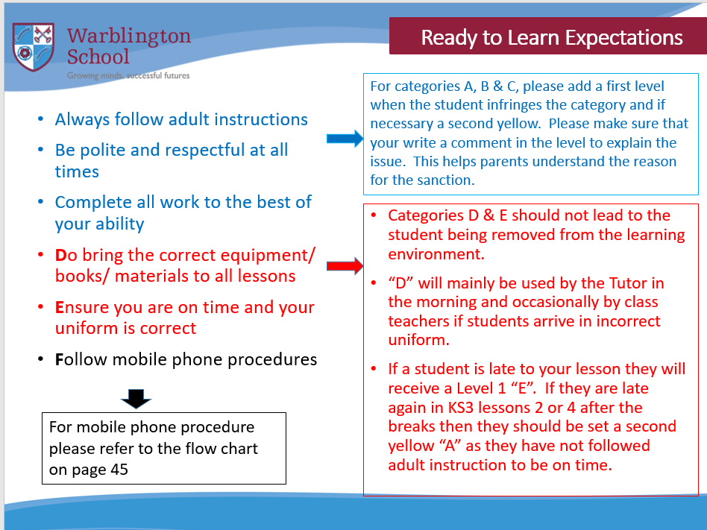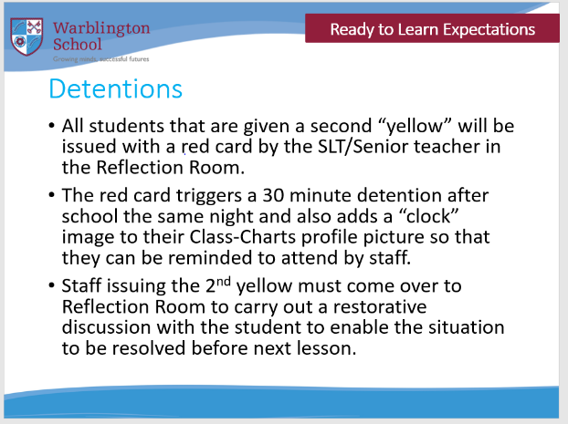

Arbor system will enable positive praise to be issued to reinforce correct behaviour expectations. It also enables levels to be set swiftly and for you to identify students in your lesson who may need reminding about their detentions.

Continual Tutor checks to support “Ready to Learn” expectations D & E.

Students to be set a first “yellow” on the day they have aspects missing and second “yellow” if they continue within the same week to not correct it. Phone calls home should be made to encourage compliance when they reach -10 behaviour points.

**Class teacher use of the “Ready to Learn” system.**

### Behaviour System Triggers



|  |  |  |  |  |  |
| --- | --- | --- | --- | --- | --- |
| Trigger Point | | | Flexibly Consistent Actions | | |
| Trigger 1 | Level 2 D or E  (Tutor) | **Tutor must verbally notify student in AM Tutor.**  30-minute same day detention in IT3.  (Automatic Class Charts notification home)    **RJ discussion with teacher setting**  **the level essential.** | | | Heads of House process detentions and escalate if necessary. |
| Second Yellow  (Class Teacher) |
| Level G issued | 15-minute detention at lunch time (Tec4) or after school in IT3 | | |
| Trigger 2 | Undesirable Level | HoH consideration for sanction following generic agreed guidance. | | | Heads of House to use ‘case by case’ decision for completion of WAVE. |
| Level 2 “F” | Extended Day in WAVE  Reflection Booklet and discussion completed with students (VWT) | | “Flexible” approach to be used based around: -   * Students punctual attendance to WAVE. * Students compliance with Ready to Learn expectations. |
| Truancy |
| Behaviour Triggers reached  (Based around points) |
| Targets signed off in discussion with HoH during the day |
| Trigger 3 | “Serious misbehaviour” | Behaviour Policy followed alongside a “case by case” approach. (JFR / MHL / HoH | | | |

Written Statement of Behaviour Principles

* Every student reminded they have the right to feel safe, valued and respected, and learn free from the disruption of others
* All students, staff and visitors are free from any form of discrimination
* Staff and volunteers set an excellent example to students at all times
* Rewards, sanctions and reasonable force are used consistently by staff, in line with the behaviour policy
* The behaviour policy is understood by students and staff
* The exclusions policy explains that suspensions and expulsion will only be used as a last resort, and outlines the processes involved in permanent and fixed-term exclusions
* Students are helped to take responsibility for their actions
* Families are involved in behaviour incidents to foster good relationships between the school and students’ home life

The governing board also emphasises that violence or threatening behaviour by any individual on the school site will not be tolerated in any circumstances.