



Warblington School

Executive Self-Evaluation

**April 2023

**Introduction**

Our vision is to be a **centre of excellence** at the heart of the **local community** by delivering an **exceptional education** for every individual through **consistently inspirational and challenging teaching**; where we show **pride in our exemplary standards** as together we **celebrate** reaching our **aspirational goals**.

## Contextual information

* The school has 738 students on roll (below national 980) however the population is rapidly increasing, 16% increase from Oct 21 to Oct 22 and is full in year 7 and 8 from Sept 23
* The proportion of pupils on **free school meals** is **29%** (National: 25%), with those eligible for the pupil premium 35%
* The proportion of pupils from **ethnic minority** backgrounds is 12**%** (National: 31.3%) and increasing
* **6%** pupils have **English as an additional language** (National: 14%)
* The proportion of pupils with **EHCP** is **3.6%** (National: 3.1%)
* **21.7%** pupils are on **the school SEND register** (national: 14.9%)
* We are part of Hampshire LA, which is the sixth worst per pupil funded LA in the country, and work closely with a local soft federation of schools.
* Stability (percentage who were an in year admission) is 14%, which is in the top 20% of schools nationally (Average 8%)
* Students join us from over 15 feeder schools, with various starting points on entry. Full in years 7 and 8 from Sept 23
* Currently overseeing a large building project to ensure the current main, historically listed building provides adequate heating and ventilation.

## The Quality of Teaching

* Whole school monitoring in Spring Term 2023 showed greater consistency of teaching.
* The strengths in teaching across the school include:
  + Ready to learn criteria are used with pupils to ensure the standards expected in the lesson are known from the start.
  + SEND provision – pupils identified as SEND have an individual pupil profile highlighting strengths, areas for improvement and strategies to use. Strategies are clearly visible in 85% of classes, however building expertise remains a key priority as student needs become more diverse.
* **Strong teaching** exists in nearly all teams, and is particularly strong in English, History, Performing Arts, PE and computing. There are known weaknesses in Science and previously identified areas of Maths and MFL are quickly improving to meet the required standard expected.
* Staff turnover has been low and where positions have become available, we have been able to quickly recruit strong teachers to fill positions. 8% of the staff are Early Career Teachers (ECTs) and just under a third of the staff trained or qualified during the Covid pandemic.
* **Weaknesses** with staff in MFL and Maths have been dealt with swiftly and effectively though capability or the coaching programme. Current weaknesses in science are being rigorously addressed, with the support of Hampshire.
* **Performance Management is known as Professional Growth** and uses the Great Teaching Toolkit to help provide individualised professional development to all classroom based staff. Observations of teachers are regular and those who are a concern are on our coaching programme or capability.
* **Professional development** is of high priority with staff responsible for continually updating their professional learning journey as well as uploading evidence contributing to the success of their targets.
* The school is committed to providing a broad curriculum, with over 60% entering the Ebacc in 2023. British Sign Language has been introduced in Sept 22 as another language option. A large variety of options are available, despite the size of the school.

## The Quality of Leadership

* SLT have high visibility and are approachable – they are all assigned a ‘duty day’ where they are highly visible for the whole day.
* Leadership at all levels valued and given high quality CPD using the NPQ Qualifications. Use of apprenticeship levy to improve CPD both with teaching staff (NPQs) and support staff (for example network manager and business manager)
* A school-wide restructure will be completed by August 2023 with a smaller, more focussed SLT structure and new subject leads introduced.
* Fully staffed, with subject experts, with no vacancies

## Behaviour and Safety

* **Attendance** remains a focus post-pandemic, with the school’s attendance close to national figures, but above local figures. Following a restructure of the inclusion team, an attendance and welfare team are key in driving the
* Pre-pandemic, there was a **considerable reduction in persistent absentees**, however this figure has increased post pandemic. It remains a focus to re-engage these students as a matter of urgency with a whole school approach.

## Improvement priorities from SIP

**Strategic Priority 1 – Quality of Education**

*Intent* – The school’s curriculum is inspirational, ambitious for all and very much based on the notion that knowledge is powerful.

*Implementation* – Students have a consistently high-quality learning experience in every subject area. Adapting the teaching to individual need is the key CPD for 22-23

*Impact* – Assessment (both formative and summative) enables students to achieve to the best of their ability. Targets are no longer set based on FFT, instead on the school achieving continual improvement.

**Strategic Priority 2 – Behaviour and Attitudes**

Eliminate low-level disruption from our classrooms

**Strategic Priority 3 – Personal Development**

We will continue to develop pupils’ character, the set of positive personal traits, dispositions and virtues that informs their motivation and guides their conduct so that they reflect wisely, learn eagerly, behave with integrity and cooperate consistently well with others

**Strategic Priority 4 – Leadership and Management**

All leaders will be highly ambitious for the school and demonstrate an uncompromising and relentless drive for excellence and continual improvement

**Key areas for improvement in the last inspection**

|  |  |  |
| --- | --- | --- |
| **Ofsted Point** | | **Action So Far** |
| Increase the effectiveness of teaching by: | – teachers making clear to all pupils the high expectations that they have for what pupils should achieve | Behaviour for learning system completely reviewed with a new system of A-G’s introduced. These were developed with staff and student input and implementation began in 2019. Fixed term exclusions (suspensions) are higher than average, however the average length is less than one day. This was a focus of the LA Inspection in April 2021 where it was clear that these exclusions served a direct purpose to engage the parents with their child’s education. *“All groups are positive about the management of pupil behaviour and are happy that expectations are clear and followed up properly.” LLPR Oct 20* and this has also been evident in a number of LA monitoring visits since [QUOTES].  The school has joined the DfE behaviour hub programme for 2022-23 and the audit and visits around that have indicated that the behaviour has improved with a number of rules tightened as a result of this focus. (3 minute late bell being an example)  Uniform has been revamped to include the newly introduced house system. This was in conjunction with student and parent voice to ensure that standards were high but cost-effective ways of maintaining consistency were met. Uniform costs are benchmarked with local Federation schools and 2nd hand shops introduced to ensure all students are able to meet the expectations.  Staff now fully teach in their areas of expertise, meaning they are able to fully develop the curriculum and teach the subject with the relevant depth required to ensure good understanding. We have seen the number of students achieving the top grades since 2018 steadily increase each year.  Achieving the Quality in Careers award is the first external evidence of our reworked careers programme meeting a national standard. Warblington is the first school in Hampshire to achieve this under the new framework.  The curriculum is now structured to ensure an ambitious vision of 95% of students achieving the ebacc, whilst maintaining the personalisation required to ensure all learners have the relevant skills to progress into the next phase of their learning. Students who are unable to access the traditional GCSE route are working through a pathway that includes BSL and other languages to ensure a breadth of curriculum. |
| – following the school’s feedback policy when scrutinising pupils’ work | The assessment and feedback policy has been rewritten to ensure that any feedback is worthwhile and ensures students make progress. Pink and Green highlighters are used to quickly assess work and highlight where students have worked well and where they see pink – to think about what they have written. Post Covid, this has been reviewed again in 2023 as assessments needed to be even sharper and more precise to ensure gaps were identified quicker and acted upon faster – meaning the use of live feedback in the classroom became more relevant. In subjects such as maths, students have become used to a checklist, showing them what and how to improve. |
| – developing pupils’ discipline and pride in the presentation of their work. | As part of our ‘Ready to Learn’ programme, all students now come to lessons with a fully equipped pencil case, which is checked daily by the tutor. This ensures they have the tools with which to complete their learning and are ready to begin with a ‘Do Now’ which is on entry to every classroom. Learning begins from minute one.  Expectations in terms of presentation are clear to students and are regularly reinforced, with middle leaders, SLT and governors regularly monitoring the quality of work. |
| Improve pupils’ progress, by | – continuing to support sharing of the best teaching practice within and between subjects, to further improve consistency in the quality of teaching | Since 2018, the school has had a relentless focus on improving the quality of teaching. Beginning the focus on ensuring all lessons contained a Do Now at the start, meaning lessons began promptly which is now embedded practice. Work with Hampshire Inspectorate has led to a coaching team set up to help those falling below the Warblington Standard and to share good practice. In Sept 2021, this coaching team is now a team of 8, led by an AHT. Key to this is maintaining the groups mentality that “when a flower doesn’t bloom you fix the environment in which it grows, not the flower.” As a result, a whole school monitoring of the quality of education saw strengths in quality of work, high attitudes to learning, consistent starts to lessons, good questioning and challenge being an integral feature of lessons*. “There have been significant improvements in teaching and learning, as seen through the learning walk and through the staff surveys. Hampshire Inspectorate and Advisory Service, March 2022*. Outcomes in all year groups have improved. Where subjects have fallen below the standard, action has been taken quickly to ensure the standards are met and the quality improves. Thinking Hard is embedded in all lessons, to ensure needs are met. 2022-23 there ahas been a focus on meeting the needs of all learners since the school has seen a significant increase in EHCP students and a much larger percentage than both Hampshire and National of those on the SEN register. |
| – checking that staff consistently challenge all pupils in lessons, particularly in the humanities and modern foreign languages | Thinking Hard strategies are used in lesson to ensure that students keep thinking and therefore learning. High quality questioning was seen in a whole school monitoring and subject experts have built challenge into their curriculum roadmaps which are displayed in every curriculum area. Bucket 2 subjects have seen a significant rise in outcomes in all year groups, some of which can be attributed to careful curriculum sequencing, but also to the increase in expectations. MFL has seen a major growth in staffing as a result of the number of students picking languages and also with the new structured curriculum. In humanities, the curriculum structures have been complete restructured ensuring an appropriateness of content to age related expectations. As a result, a greater number of students are achieving in these subjects. Whilst we are seeing this in years 7 to 9, we expect to see significant jumps in KS4 in line with this. The percentage of those achieving the Ebacc in 2022 was in line with the national average (21%) |
| – improving the tracking and analysis of pupils’ progress so that the most successful practice is easy to identify and develop further. | Assessment system has been completely redesigned and simplified with subject dashboards produced each data drop to name those students who are not at expectations. In Planning 4 Progress time, (P4P) staff analyse their groups and develop action plans based on classroom interventions. At Key Stage 4, mentoring groups are set up using Horsforth Quadrants, where mentors are allocated based on specific groups. Careful in class assessment has seen progress across all year groups increase. For 2021-22, this work was carefully targeted around the disadvantaged group, and outcomes at KS4 saw the gap close from the 2019 exam series, a trend that was not replicated nationally. |

**Self-Evaluation of ‘Quality of Education’**

Despite being smaller than average, we pride ourselves on our curriculum offering and the fact we celebrate and recognise all subject areas, whilst acknowledging academic excellence.

## Intent

The curriculum at Warblington underpins our goal of ensuring that students experience a broad and balanced curriculum, delivered by high quality teaching. Our curriculum is coherently planned, personally tailored and designed to ensure all students receive a curriculum they are entitled to, to ensure they achieve their best. Subjects have carefully planned and sequenced their learning journey, making necessary adaptions post pandemic, which are displayed as road maps around the school site. This knowledge is carefully sequenced so students have a deep understanding of the subjects they study. Emphasis is placed on careers and where the next stage of their education may take them as we have academic ambition for all students.

The school's curriculum is national curriculum compliant and meets the needs and aspirations of learners. Years 7–11 represent a five year continuum, merging aspects of both Key Stage 3 and Key Stage 4. All students begin their Warblington journey studying the full range of subjects at Key Stage 3. Our Key Stage 3 to 4 transition year in Year 9 enables the curriculum to remain as broad as possible for as long as possible, with option choices being made in the spring term and started in the summer term. This enables the Key Stage 3 curriculum to be delivered across KS3 and for students to make knowledgeable choices for their KS4 years. The majority of students go on to study a language as we deem it as important given our proximity to the continent. Since September 2022, this has included British Sign Language and the school actively participated in Sign Language Week in March 2023.

**“Thank you for all the hard work you and your colleagues do to ensure that pupils at Warblington are able to access and engage in high-quality music education. Your dedication to offering and delivering a broad and balanced curriculum is both welcomed and celebrated.”**

*Music Mark Award, September 2020*

**Implementation**

We are fully staffed, by specialists, in all areas of the curriculum. September 2022 was the start of the second year where all lessons are taught by subject specialists with excellent subject knowledge. Consequently, there is a greater level of consistency across the school.

Lessons are well planned, focused and purposeful using our GROWTH model which was developed by the teaching and learning team in the school. Each lesson starts with a ‘Do Now’ to ensure a prompt start. Activating hard thinking strategies have been introduced to ensure lesson time is used productively and there are generally high levels of student engagement. Teachers are knowledgeable in regards to student need and therefore provide appropriate support and challenge, which enables most students to learn well. An ethos of continuous reflection and improvement amongst our staff is securely established. Learning Support Assistants have developed their own area of specialism to ensure students with SEND are well supported both in and outside of the classroom. The school is part of a local SEND project with the EEF, with CPD from Sally Franklin, researcher for Maximising the Use of TA.

Teaching is monitored by senior and middle leaders on a regular basis through lesson observation, lesson drop ins, learning walks, book scrutinises and student voice.

The use of the new school feedback policy has had positive impacts by shifting the focus from marking to planning – reducing teachers’ workload and ensuring that teaching is more responsive to students’ needs.

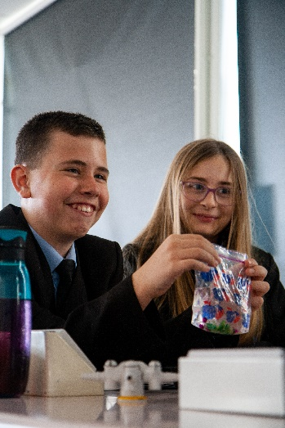CPD time has enabled all staff to be involved in ensuring classroom environments are designed to maximise learning opportunities, as well as developing student resilience and independence.

**Priorities for Development**

* The school's curriculum is continually evaluated to ensure it continues to meet the needs and aspirations of learners.
* Targeted and differentiated CPD enables all staff involved in teaching to develop their subject knowledge and subject specific pedagogy.
* A continuation of the work on how students learn and how memory works so that spaced retrieval practice is evident in every lesson.
* Literacy across the curriculum is supported with reading for purpose and reading for pleasure involving the introduction of STAR; Sit Together and Read time.
* To further improve the quality of planning, homework, feedback and questioning.
* Ensure that teachers consistently use assessment information to plan learning that provides high levels of challenge for all students.
* To further develop activating hard thinking strategies within all lessons across the school.
* To extend the teaching and learning team into the school’s coaching team to improve the quality of teaching and learning through an approachable support network.

**Self-Evaluation of ‘Quality of Education - impact’**

Using robust tracking and monitoring we have seen increases in all subject outcomes.

## Key Stage 4 Progress

Warblington’s 2022 Progress 8 (P8) was significantly below average with a three–year average Progress 8 of -0.62. Whilst disappointed wit the P8 score in 2022, the cohort size of 94 must be taken into account. In the 2022 Cohort, 3 joined in year 11, 3 sat non-P8 qualifications at The Key Education Centre and 2 students found attendance challenging post Covid. Whilst a more detailed breakdown is available here, with the 91% not mentioned above, the statistics are as follows:

Eng & Maths 4+: 60% (⬆from 54% in 2019)

Eng & Maths 5+ : 38% (⬆from 31% in 2019)

Ebacc 4+: 23%(⬆from 16% in 2019)

Ebacc 5+: 10% (⬆from 8% in 2019)

Attainment over time is increasing as a result of a curriculum restructure, a more robust Key Stage 4 programme and upskilling specialist staff. Mentoring programmes, bespoke and innovative revision programmes and detailed data tracking have enabled interventions to be successful. The procedures used in 2020 and 21 to accurately assess outcome have been further refined to ensure robustness. In almost all cases, due to the success of remote learning in lockdown, all courses were completed, leaving students in a strong position in their post 16 options. Predictions for 2022 were accurate against final outcomes, indicating an increase in professional knowledge.

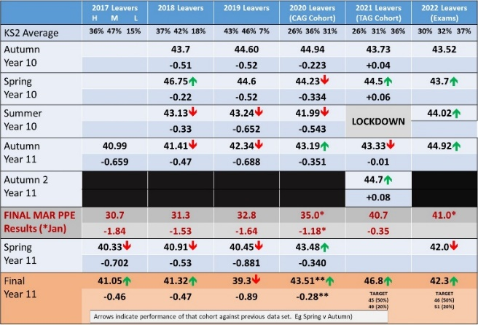

*The tracking diagram above shows tracking data over time.*

Recent PPE’s for the 2023 Cohort are showing the attainment is likely to increase again, despite another small cohort.

## Key Stage 4 Attainment

As a result of the measures above, along with careful curriculum planning, Warblington’s Attainment 8 (A8) has been steadily increasing.

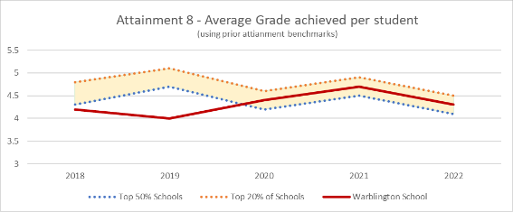

We pride ourselves on ensuring students have a broad curriculum and students are actively encouraged to choose a language to study at KS4. As a result, our Ebacc 4+ statistics are favourable, and put us in the top 50% of schools nationally and will improve as a result of an increase in lesson time to study the subjects in more depth.Chart

In maths and English, students now perform broadly in line with national average.

**

**

A particular area of focus for Warblington has been around the disadvantaged student offer. Following work carried out with Marc Rowland, using his ‘Building Blocks for Excellence’, In 2022, the average grade for disadvantaged students was half a grade below that of their non-disadvatnaged peers – a reduction from the 2019 data. This is in contrast to many national and local schools where they have seen the gap widen post school closure, indicating work during and post school closure has had significant impact on those students. Students with an EHCP make more progress at Warblington than their peers nationally.

## Destination Data

Data shows that none of the 2022 cohort were NEET and the number of students going onto Level 3 courses in 2022 was 63%, an increase of 11% from 2018. 61% went into STEM related courses. The number of intended destinations had risen from 6 in 2018 to 14 in 2021. This is a direct outcome of the increase in importance placed on aspirations and a high quality CEIAG, acknowledged in our Hampshire Inspectorate report in April 2021. We achieved the Quality in Careers award in December 2021 – the first school in Hampshire to do so under the new criteria.

## Priorities for Development for ‘Quality of Education – Impact’

* Continue to raise the proportion of students securing the Basics 9–4 and 9–5 in English and Maths to bring results close to being in the top 20% of schools
* Continue the work with disadvantaged students and ensure that **those impacted most by school closures continue to make the progress expected.**

**Self-Evaluation of ‘Behaviour and Attitudes’**

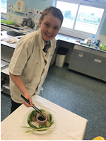As a result of successfully introducing our ‘Ready to Learn’ system, we believe the behaviour and attitudes are good. We conclude this because:

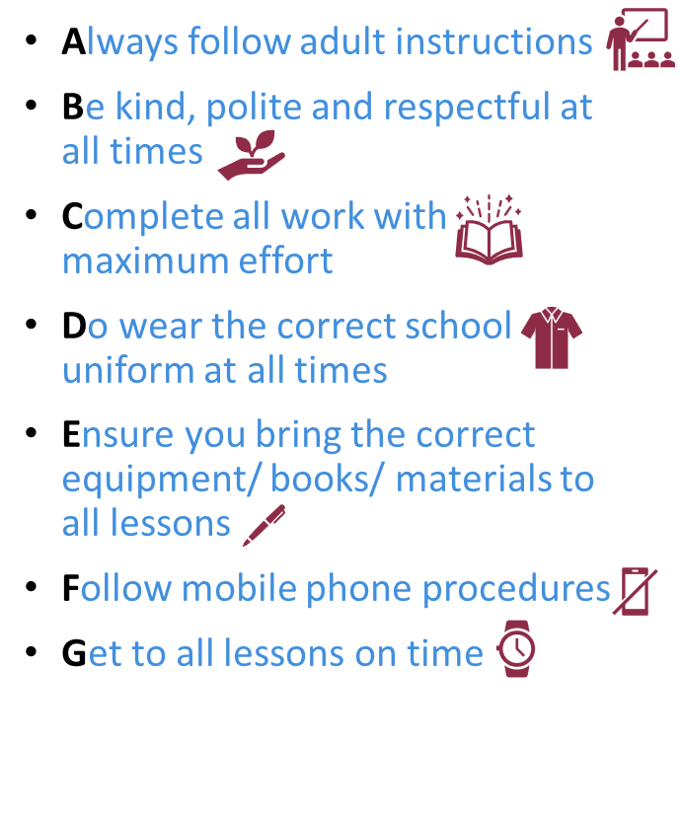**Relationships between students and staff** are extremely positive and the overwhelming majority of students engage actively in their learning, displaying an enthusiasm to make progress in lessons and other learning opportunities. Our A-G’s are understood by all and consistently applied. The introduction of the ‘G’ - get to lessons on time – was added as a response to some unnecessary lost learning time identified. A-F expectations were developed alongside the students. Our work witrh the DfE Behaviour Hub programme has refocused our work.

**Students take responsibility for their behaviour**. They are kind and respectful towards each other and their teachers. Disruptions to learning are rare, yellow and red cards used effectively ensuring that rare disruptions are swiftly dealt with. A duty member of SLT walks the school each day to ensure learning is focussed, with no opt out for students. The school has an effective system with tiered levels of support that meets the needs of THE most challenging students and that supports our drive to deliver uninterrupted Quality First Teaching. **Students feel safe at school. Bullying is rare**. Reported incidents are followed up promptly and restorative approaches underpin the work done to rebuild relationships. Parent and student surveys evidence this work.

**“The senior leaders responsible for the design and implementation of the behaviour policy should be congratulated as the impact of this was clearly evident. All staff and pupils commented upon the improvements in behaviour due to the change in behaviour policy.”**

*Hampshire Inspectorate and Advisory Service, January 2020*

The school has maintained its **inclusive pastoral system** that very effectively supports all students, with a particular focus on those pupils eligible for PP funding. We have always been seen as a school who go the extra mile, often providing opportunities for ‘fresh starts’ for students and with the developments in our careers team, this has had a much greater focus on ensuring outcomes match this commitment. A member of the Senior Team now chairs the management panel of the local behaviour centre, The Key.

**“Behaviour seen throughout the day would align with the self evaluation, with the school being calm and orderly, with pupils following staff instructions with respect.”**

*Hampshire Inspectorate and Advisory Service, March 2022*

Where individuals have particular needs, their behaviour improves through a combination of Pastoral Support Plans, intervention work from our inclusion team and outside agencies.

When comparing the school’s rate of exclusion with national figures, **the rate of suspensions are higher than average** but this has been used to implement the ready to learn system. Following each exclusion, parents have been brought in for a meeting to discuss and reflect on behaviour and move forward. The school is in the bottom 15% of Hampshire schools for length of suspension, and the trend is suspensions are decreasing. Less than 2% of the school population have had more than one suspension. Comparison with Data on permanent exclusions points to a remarkable record of inclusion.

**“I just wanted to thank you for your continual support and updates on the current situation. It's been a comfort to *this student* to have some form of routine over the past weeks and we were really touched by his teachers checking in to see that he was ok and not stressing too much to get his work done.”**

*Parent Quote, April 2020*

The vast majority of students at Warblington value their education and rarely miss school. Attendance is a close focus for the school, particularly post Covid-19 lockdown, through awards and praise in tutor groups and assemblies. We issue fixed penalty fines where necessary, but seek to work alongside families to improve pupils’ attendance.

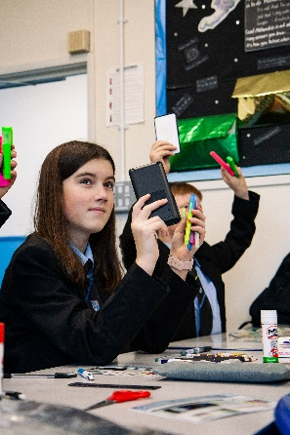Attendance is now the key responsibility of all stakeholders and is currently exceeding national figures. Warblington has a dedicated Attendance Officer and an assigned AHT who are passionate about attendance and work alongside the House Leaders and tutors to drive improvement attendance. As a result of this, we saw every child return to school in September 2020, following school closure. 98% of students attended school on Christmas dinner day in December 2021.

## Priorities for Development for ‘Behaviour and Attitudes’

* Further increase the levels of attendance, while further improving the attendance of disadvantaged students and SEN with/without EHCPs.
* Continue to tackle low-level disruption in lessons. Ensure staff have strategies to deal with this and follow the school’s procedures
* Work with the DfE’s Behaviour Hub team to improve behaviour for those persistent reoffenders.

**Self-Evaluation of ‘Personal Development’**

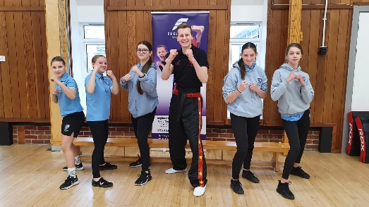The staff know every child as an individual. This enables us to personalise the experience for every child and get know each child individually.

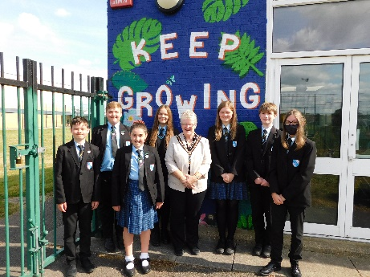The pastoral team at Warblington is a real strength. Our house leaders are central to this team, working with their tutors to provide our first wave of support via our daily, structured tutor sessions and assemblies. These sessions address many of the opportunities to support the SMSC of the students and to ensure that they are safeguarded. Alongside this team, we have our second wave of support in which students mental and physical health is supported via our health and wellbeing and inclusion team, our student support manager and our attendance lead. Through this centrally located team, students are effectively provided with mentoring, counselling and medical support as and when it is needed.

The transition from Year 6 to Year 7 is particularly strong and regularly praised by parents. Whilst the Year 7 team (Year Leader and tutors) remains the same each year to ensure a thoroughly supported transition to secondary education, the remaining tutor teams stay with their students from year 8 to year 11 to enable tutors to develop very detailed knowledge of the students, excellent relationships and to provide them with effective guidance.

**“The reason for my email is mainly to say how grateful I am for the care and respect that xxxx receives from the school. In particular Mrs Elvy, who goes above and beyond. [My daughter] really appreciates the support that Mrs Elvy gives her and thinks of her as her ‘school Mum’, which means she trusts Mrs Elvy and she is more likely to engage with and open up to her.**

**I realise teaching can be quite the thankless career so I wanted to make sure that you’re aware that we really do appreciate the support.** *Email from a parent, May 2022*

Personal development is supported by the school’s extensive range of community partnerships and through the school’s enrichment programme. Every Tuesday afternoon, the personal development curriculum is taught, focussing on relationships and sex education, safeguarding, diversity and equalities and careers.

There are a number of extra-curricular activities including sports teams covering each year group and many students take part in our sports week. Warblington is proud of its performing arts faculty, which celebrates its success through our school productions, musical, and dance performances. The school has recently set up an eco-committee, which is actively campaigning to promote environmental awareness, e.g. improving recycling, reducing waste and litter, and recently achieve the green flag!

The use of tutor time has been developed to increase the opportunities to prepare students for life in modern Britain alongside the personal development aspects of our Enrichment lessons. Each week students will celebrate national memorial event and aspects of SMSC through year assemblies. In addition, each week students across the school will consider a discussion topic for the week and an opportunity to consider an aspect of cultural capital. It is anticipated that these sessions will focus on social and moral aspects of life, safeguarding and environmental concerns.

**“There are 11 children on reduced hours provision (RHP). Leaders have a very clear and comprehensive understanding on the children’s personal histories, family situations, health needs and education experience.**

**Each case and the use of RHP has a clear rationale with pathways for increasing children’s hours, along with structures to ensure Year 11 pupils potentially achieve 5/7 GCSEs, allowing them to progress onto further education and a career of their choice. RHP has also been used to reduce Elective Home Education (EHE) successfully with remote learning a clear pathway on reintegrations back into school. The processes around RHP have been tightened up with risk assessments in place, communication with parents and other agencies to safeguard children in place. Pleasingly, RHP is not used for behaviour or SEND reasons, most are medical/mental health.”**

*LLPR report April 2021*

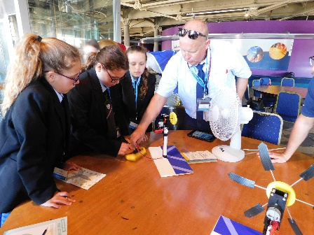Through our enrichment programme, our tutor sessions, our assemblies and our curriculum, the school goes to great lengths to prepare students positively for life in modern Britain and to promote “British values”. We have a dedicated careers team, including a Level 6 Careers Leader who lead a career programme underpinned by the Gatsby Benchmarks. Careers education is taught by a dedicated team of teachers and occurs across Key Stage 3 and 4 through the careers strand in the enrichment programme.

Additional careers guidance at Key Stage 4 is given by out impartial careers adviser. Together, these provide students with information about a wide range of pathways and local providers, ensuring that our students successfully make the transition from our school to further education, apprenticeships or employment. Our destination data is in line with the national figures and in 2021 and 2022 we saw students move on to a much larger range of post-16 establishments. We are affiliated with the Careers Development Institute (CDI) and have achieved our Careers Mark award and the Headteacher has recently completed his MA (Ed) on the impact of careers provision to further enhance the work in school.

**“Pupils were unanimous in their positive praise of how the school prepares them to reach their goals and career aspirations. On the day of the visit career interviews were taking place, with 100% of the year group involved.”**

*Hampshire Inspectorate and Advisory Service, January 2020*

The school’s clear zero tolerance approach to derogatory language or intimidatory behaviour reflects the school’s open culture. Students are asked to reflect on language used in our reflection room and students are happy to report others who use such language. The school works well with the police to reinforce the message where required.

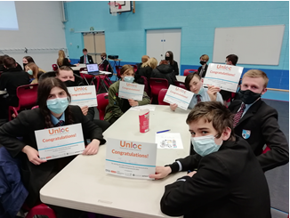Warblington understands that everyone will develop during their time with us, but this may be at different rates and different times. Some may need to use our successful Gateway provision to support them in their transition to us; some may use the Student Hub at break times to make them feel more secure; but all students acknowledge that there is always a member of staff who can support them and the safeguarding culture means staff are always on alert with the mindset “it could happen here”.

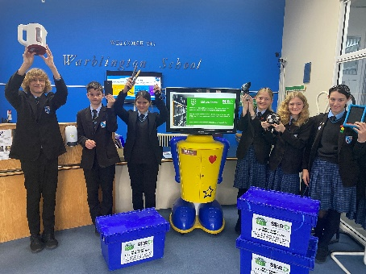**“I've been at Warbington nearly two years now and it’s changed my life, and brought out a side to me that I've never seen – I no longer feel weak and vulnerable. Warblington took me in, gave me a chance and provided me with the help and care that I needed and they are still putting up with me now! I guess school is a reason I haven’t given up on myself, so I just wanted to say thankyou.”** *Taken from an email sent to the Headteacher from a student, September 2022*

## Priorities for Development – ‘Personal Development’

* We will continue to develop students’ character, the set of positive personal traits, dispositions and virtues that informs their motivation and guides their conduct so that they reflect wisely, learn eagerly, behave with integrity and cooperate consistently well with others.
* Embed the role of the tutor to include supporting students’ wellbeing, resilience and to recognise how to keep themselves safe and healthy.
* Further raise the profile of careers education across the school.

This year work towards achieving ‘The Quality in Careers Standard’, the national quality award for careers education, information, advice and guidance (CEIAG) in schools.

* Through strong leadership across the ‘Careers and Personal Development’ further develop our personal development curriculum to build skills and behaviours that will support students for life.
* Develop further a student approach to preventing all forms of bullying, including online bullying and prejudice-based bullying.
* Continue to raise mental health awareness and to promote the emotional wellbeing of all students.
* Ensuring the Mental Health Support Worker, based on site, embeds themselves in Warblington’s environment.

**Self-Evaluation of ‘Leadership and Management’**

Leaders set about ensuring that across the school the building blocks for excellence are in place, creating a supportive culture where we all learn together.

We have a simple ambition: to be excellent in all we do. We want students who come to Warblington to experience a personalised, excellent education which is better than any other local school. Our vision is articulated through documents such as the School Improvement Plan (SIP). Whilst it establishes a series of operational targets, it also contains a broader set of goals and values that the headteacher and governing body wish the school to aspire to. All SLT are responsible for the SIP.

**“The headteacher has revamped and rewritten much of the school’s documentation, in conjunction with his senior team. This demonstrates a more focused approach, with clarity in all aspects of the school’s work. All documents are clear, with progression and milestones for each action. Teachers spoke very highly about the senior team and their high expectations. There is a clear vision guiding all of the school’s work ‘Excellence is an Expectation’”.**

*Hampshire Inspectorate and Advisory Service, January 2020*

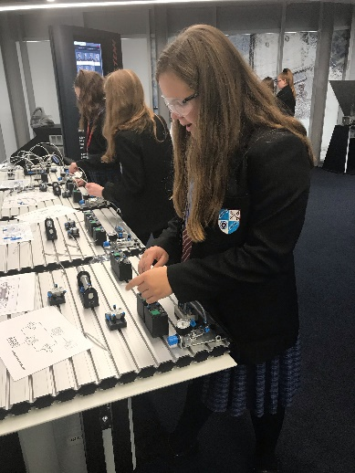The SLT is a cohesive and highly effective strategic and operational team. The middle leadership has been completely restructured since 2018 and the SLT have all completed NPQ qualifications since taking up their posts.

Staff wellbeing is, and remains a priority for the school. This varies from in house changes to policy, listening to surveys through to working with external groups like the University of Bristol on their ‘Reimagining the Diary’ project. Staff morale is high and relationships between staff and students are strong. Staff provide ‘above and beyond’ care, which underpins our culture and success. Warblington is fully staffed with teachers who are highly qualified in their subject area and has little staff turnover. Where needed, leadership structures are changed (for example in maths) to ensure staff development and the best outcomes for students. The curriculum has been completely reworked to ensure that all teachers teach within their specialism. We have a clear focus on staff workload and wellbeing. Staff are consulted regularly over the impact of policies and their opinions sought.

Strong governance with detailed minutes/impact statements and resulting actions demonstrating high levels of monitoring, challenge and support. Governors have undertaken regular skills audits and self-evaluations. Their combined experience reflects a diverse range of skills and are working with Hampshire Inspectorate and Advisory service to further develop the role.

Rigorous Monitoring & Evaluation is now in place. This identifies clear strengths and weaknesses understood by all SLT and action is taken to impact on outcomes. Priorities for improvement are precise, shared and regularly monitored.

All safeguarding procedures are fully in place. The safeguarding team work closely together to support our most vulnerable students, with our safeguarding lead setting up and chairing a safeguarding federation group to aid support. A DSL chairs the local federation group of DSLs and a weekly meeting of the team of DSLs provide regular, timetabled, supervision opportunities.

**“The support staff and teaching staff spoken to during the visit were very clear that they would report any concerns about a child or a colleague and spoke confidently how they would do so. There is a real sense of it could happen here and that children come first.”**

*Hampshire Safeguarding Inspectorate, Sept 2019*

We have a clear and persistent focus on improving teaching and learning which has gone back to basics to ensure we keep things simple, but execute them brilliantly. Research is used to make decisions about teaching and learning evidence based and have a real impact on student progress.

**“During the learning walk all pupils were engaged in their lessons. It was evident that teachers had a stronger presence and command within the classroom environment, with subtle cues to engage pupils who may be off task or unsettled following a transition. These ‘behaviour of learning’ techniques were evident across the school, with teachers skilfully using eye contact, hand gestures and body language, without interrupting the flow of the lesson. This ensured any low­level disruption was addressed swiftly and meant behaviours did not manifest into something more.”**

*Hampshire Inspectorate and Advisory Service, March 2022*

Systems to support teachers at all stages of their career, including the new ECT programme, are available. Excellent practice programmes are developed and through the use of structured coaching and mentoring programmes, ensure strong teaching across the curriculum. This is evaluated through monitoring and observations of effectiveness undertaken by a range of leaders. NPQ qualifications are available for all middle leaders to undertake.

**“There have been significant improvements in teaching and learning, as seen through the learning walk and through the staff surveys. Staff surveys extol the positive aspects on the continuing professional development (CPD) and coaching they are receiving…** **The CPD programme is very comprehensive and directly linked back to the self evaluation form (SEF) and SIP”**

*Hampshire Inspectorate and Advisory Service, March 2022*

We continue to work with all stakeholders to develop a culture of high expectations. The culture established is a relentless focus on high standards in all aspects of school life: learning, behaviour, attitude, uniform, attendance and punctuality. We, alongside the students, have changed the uniform and behaviour policy. This has already seen significant impact.

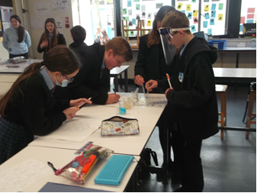PPG spending is fully accounted for and impact evaluated rigorously. Attainment and progress of all groups of students is a key priority for the school. One AHT has responsibility for overseeing vulnerable groups.

Leaders at all levels are supported to improve, or maintain, the highest levels of achievement and personal development for all students over a sustained period of time.

The school’s budget is effectively managed and directed fully towards student progress, particularly in supporting students with learning needs/ from disadvantaged backgrounds, to continue closing gaps in achievement. We continue to work within our means, despite being in the 5th worst funded county in the country.

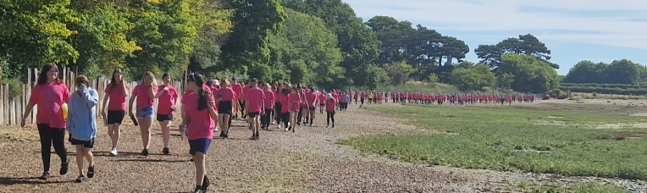The school involves itself in a variety of community projects and supports local charities. It prides itself on being an integral part of the local community. In the summer of 2022, the school raised over £4000 and saw the entire staff and student body don pink shirts and run or walk in the local community in support of the Race for Life. It is quickly becoming the school of choice in the local area due to the delivery of a successful transition campaign targeting years 5 and 6. Numbers on roll have increased from 575 in September 2021 to 681 in September 2022.

## Priorities for Development for ‘Leadership and Management’

* Self-evaluation continues to be rigorous and captures a realistic picture of the school’s performance. Involve all stakeholders in the formulating of the 2021–2024 Strategic Plan.
* Ensure the relentless focus on high quality teaching and learning ensures in-school variation is minimised and we continue to drive improvement in SEN/disadvantaged students’ outcomes and curriculum provision.
* Continue to ensure Governors systematically challenge senior leaders so that the effective deployment of staff and resources, including SEN and Disadvantaged funding, secures excellent outcomes for students.
* Maintain high morale and staff wellbeing, leading to strong retention at a time of multiple pressures including reduced funding, curriculum reform and issues with teacher supply.
* To ensure that teacher workload is managed and ensure policies offer efficiencies whilst maximising impact on pupil learning.
* Ensure safeguarding continues to be highly effective never losing the “it could happen here culture”.
* To continue to adapt our inclusive, innovative and diverse curriculum, to further raise achievement and meet the needs of all learners.
* Ensure that the curriculum offer demonstrates a clear progression of knowledge and skills over time responsive to on-going student need and that this is represented in pupil outcomes and experiences.