**Statement from the Governing Bodies and Headteachers within the Havant Federation of Schools**

**Attendance**

Excellent and regular attendance is essential for a child’s education to be successful. It is the responsibility of parents to ensure that their child attends school. We thank those parents who ensure that the attendance is above 95%. Absence from school should only occur in the extreme of circumstances and holidays taken in term time will not be authorised.

**What is excellent attendance?**

The graph clearly shows what all schools expect in terms of excellent attendance. 90% attendance is not good enough; it needs to be 95% and above.

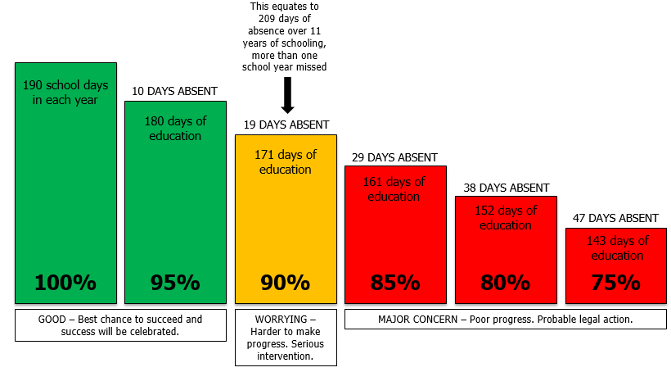

**How does attendance affect progress?**

Attendance below 95% can adversely affect the academic progress of your child and limit their social development as they have reduced access to activities that promote this.

There is a direct correlation between excellent attendance and student outcomes. Those students who have 95% and better attendance make significantly positive progress. Those students with under 95% attendance do not make as much progress as those with similar abilities across the country while those with 80% attendance make significantly less progress than those of similar ability across the country. There are always exceptions to this but overall, the statistics really reinforce and clearly show that attendance matters. If a child is not in school, they are not learning and can get left behind.

**How can you encourage good attendance?**

* **Expect your child to go to school and ensure that your child knows this.**
* **Ask your child about their day at school and talk about what they might be doing in the future at school.**
* **Approach the school earlier rather than later if you have issues with attendance.**
* **If your child’s attendance could be attributed to emotional wellbeing, please contact a member of the pastoral team who can refer to appropriate support.**

**Attendance Information:**

**Holidays**

Holidays in term time will not be authorised. Requests for absence may be authorised if there are exceptional circumstances but the length of time authorised is likely to be limited. Parents of students found to have been on holiday when either authorisation had not been granted or permission not sought will be liable to prosecution. The onus will be on parents to prove that the child(ren) were not on holiday. No form of absence immediately before or after a school holiday or a family holiday will be authorised unless evidence is provided of genuine and exceptional reasons for absence. Unauthorised absence could result in prosecution. The Local Authority retain the discretion to issue a penalty notice before the threshold is met. This might apply for example, where a parent is deliberately avoiding the national threshold by taking several term time holidays below threshold, or for repeated absence for birthdays or other family events.

**Requests for absence in exceptional circumstances**

The decision to authorise an absence due to exceptional circumstances will be based on the individual facts and circumstances and considered on a case by case basis by the Headteacher. Where an exceptional circumstance forms part of a longer absence, only the exceptional circumstance element will be authorised.

Examples of circumstances that would be considered on a case by case basis include weddings and funerals of close family members.

Absence for religious observance would be considered in line with The Education Act 1996 S444(3c) which defines, ‘any day exclusively set apart for religious observance by the religious body to which his/her parent belongs’.

In addition, absence to participate in sporting or creative activities operating at a high standard of achievement would be considered but authorised absence would be limited within any school year and documentary evidence, such as a licence, would be required.

**Absence for illness**

Hampshire County Council guidance states if your child has no temperature but has a cough, cold, headache, earache then as with adults, the medical advice is to give them paracetamol and send them to school. We will always contact you if your child’s condition worsens or if we believe their illness is contagious such as chicken pox, vomiting, etc. Please refer to the school attendance policy or the school website for further information.

If your child has been ill in the night and has had broken sleep, please consider sending them into school in the afternoon with a note. Your child may feel better and they will have the chance to attend some lessons, find out about homework and learning missed and to join their friends.

**Ongoing medical absence**

Please note regulations for schools give the Headteacher the right to consider whether to accept the parent/carers position with regard to medical absence – and may decide to unauthorise these absences. For ongoing conditions that prevent a student attending school, it will be necessary for us to request medical evidence advising that the student is unfit to attend. This must also state how long this will be for. Please note that the Education Act 1996 places the responsibility on parents/carers to provide medical evidence when requested by the school.

**Absent, but able to learn**

If your child is absent due to a long term or contagious illness but is able to work at times, please contact the school to request work. We have some online learning platforms so students can complete relevant learning at home.

**Appointments**

Medical and dental appointments should be made outside of the school day whenever possible. If taken in the school day, when possible, register for the session before attending an appointment and return to school following an appointment. As schools, we only authorise a maximum of half a day for a single urgent medical appointment and evidence will be requested in the form of an appointment confirmation message, letter, booking slip or similar. There are exceptions to this if a student is having longer or specialist medical treatment. Please be aware that the absence or illness of a student should not affect the education of their siblings. If a student has an appointment (particularly at the beginning or end of the school day) arrangements should be made to ensure that the other sibling is either dropped off or collected on time.

Remember to contact the school for any absence explaining the reason. All students should be reported ill by their parents on the first day of absence. Parents must call in every day that their child is absent. Parents are requested to supervise their child to catch up on work missed once their child is well enough.

**Persistent absence**

A persistent absentee is defined as attendance below 90%. A typical pattern of absence could look like the example below, totalling 18 days of absence in the school year. If this were to continue for five years of secondary school, then they would miss the equivalent of half of a school year.



We monitor each student’s attendance very closely, and especially those who are at risk of falling into this category. When a student’s attendance falls below 95% the following actions will ensue:

* Stage 1 – Letter home notifying parent/carer that their child’s attendance has dropped below 95% and is a concern.
* Stage 2 – Formal letter from school expressing our continued concern that a student’s attendance has not improved.
* Stage 3 – Formal letter requiring that parent/carer provides medical evidence to support absence related to illness and advising that absences will be unauthorised unless evidence is provided.
* Stage 4 - Parent/carer invited for a formal meeting at the school. Attendance contract signed (or offer and rejection recorded) – Penalty Warning given verbally.
* Stage 5 – Notice to Improve letter. Letter sent if further support would not be appropriate or has not been successful or engaged with and it is likely to change the parents’ behaviour.
* Stage 6 – Formal letter sent if parent/carer fails to attend a formal meeting on two consecutive occasions. Letter advises that a FPN or Legal Team referral will be made if attendance does not improve.
* Stage 7 – Formal letter to parent/carer advising that a referral has been made to the Attendance Legal Panel or Fixed Penalty Notice given.

At every stage it is imperative that parents/carers ensure that there are good lines of communication with the school. The school will endeavour to support, advise and provide strategies for parents/carers who are willing to engage.

Please contact the school to request assistance if required. Appointments can be made with Form Tutors, Class Teachers, pastoral staff, attendance officers, family support workers and education healthcare workers as available in each school. Parenting advice and support may be available.

**Punctuality**

Missed registration will be regarded as unauthorised absence and relevant legal proceedings may ensue.

**Further Information and Advice**

Hampshire County Council – Behaviour and attendance guidance for parents/carers can be found online at <https://www.hants.gov.uk/educationandlearning/behaviour-attendance-parents#step-6>

Hampshire County Council information for Penalty Notices for non-attendance at school: Advice for parents and carers can be found online at <https://documents.hants.gov.uk/code-of-conduct-issuing-penalty-notices-for-unauthorised-absence-from-schools.pdf>

All Hampshire advice is available via their website: www3.hants.gov.uk

If you would like further clarification, please contact your child’s school.