**Candidate Information Pack**

**COVER SUPERVISOR**

**Salary Grade D - £20,744 (£26,918 FTE)**

**32.5 hours per week, 40 weeks per year**

**Mon-Fri 08.00am-3.00pm**

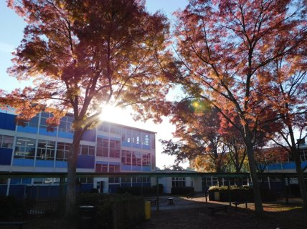

**A very warm welcome to Warblington School**

Dear Applicant

Thank you for your interest in Warblington School.

Warblington school has something quite special about it. We are a very small, but rapidly growing secondary school. At only 780 students we can do things differently here as we know individuals well. But it goes deeper than that. Everyone who visits will tell you just how welcoming the school is for new staff and students – over 40 students joined us mid-way through the year last year, with each one saying how they had settled in well and were enjoying school. Ofsted noted during their recent inspection (Jun 2023) that “*most pupils like attending this kind and caring school”* and “p*upils build strong friendships with their peers”*

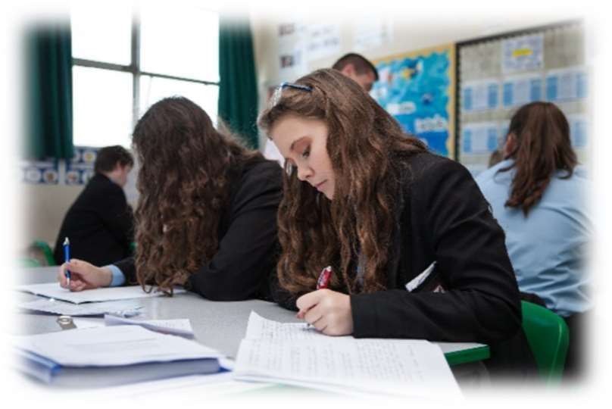It is a thriving community and I am proud to say our students are well behaved, friendly, kind and considerate. They welcome visitors and they are proud to speak of their school. Our staff are passionate about improving learning and aim to inspire and challenge the young people we work with.

We believe that children have the right to the best education and during their time with us, we aim to equip all of our students with the skills they need to flourish in modern society; to make the best of opportunities and to be able to positively contribute once they leave Warblington School.

I am pleased to say this was recognised during our recent inspection, where inspectors commented that Students *“talk confidently about what they have learned”* and acknowledged that “*A well-planned personal, social and health education programme sets pupils up well for the future, preparing them successfully for adulthood.”*

We have high aspirations for everyone who wears the Warblington School logo and we strive to improve ourselves through a clear focus on learning and achievement in a supportive environment. As a parent myself, I know that children and young people learn best in an environment which is secure, happy and caring. Our learning community works hard to create the right atmosphere and we pride ourselves on seeing each child as an individual. We take time to celebrate achievements together, whether they are academic, sporting, artistic or dramatic.

Here at Warblington, we are committed to bringing the best out of each and every student entrusted to us and being a small secondary school allows us to get to know each individual and provide them with the support they need that will enable them to thrive*.*

Curriculum is very important to us and has played a key role in our improvement in outcomes. Teachers here are passionate about the subjects they teach and we believe students need to experience a wide range of subjects for as long as possible, which is why our options process begins at Christmas of year 9 and takes effect from that Easter, allowing us time to ensure each student gets the right level of advice and guidance to help them make informed choices.

Finally, it is important to note that teaching and learning is at the heart of everything we do. Ofsted acknowledged that “*Staff know pupils very well. Importantly, they have pupils’ best interests at heart. Leaders and staff are committed to unlocking pupils’ potential”.*

I hope you enjoy finding out about Warblington School. Having access to a broad and balanced curriculum, and learning opportunities outside the classroom are key to our students developing into young adults.

I sincerely hope that we will be welcoming you into our community!

Our aim is to ensure that excellence is our expectation.

Mike Hartnell

Headteacher

**COVER SUPERVISOR**

**Salary Grade D - £20,744 (£26,918 FTE)**

**32.5 hours per week, 40 weeks per year**

**Mon-Fri 08.00am-3.00pm**

We are seeking to appoint a Cover Supervisor on a permanent full-time contract with the skills and experience to develop positive working relationships with young people.

Being a cover supervisor is an excellent opportunity for someone thinking of teaching as a career and wants some hands-on experience; or an existing teacher wanting to move away from the pressures of marking and planning but stay in the classroom. Full training will be given to the successful candidate.

**Key responsibilities**

• Provide short term cover for absent teaching staff and provide general feedback to the regular class teacher.

• Be responsible for promoting and safeguarding the welfare of children and young people you are responsible for.

• Encourage positive behaviour through the implementation of the school behaviour policy and practices, and encourage students to take responsibility for their own behaviour.

• Contribute to the overall aims and ethos of Warblington School and be a role model for students through exemplary professional conduct.

• Attend and participate in meetings as required

Excellent communication and organisational skills are essential, as is the ability to work both as a team and independently. Previous experience of working with young people is desirable and the ability to contribute to the wider life of the school will be an advantage.

Closing Date: 29th November 2024

Interview Date: TBC

**We would strongly recommend an early application as we reserve the right to close this**

**vacancy early if we receive sufficient applications for the role.**

**JOB DESCRIPTION**

To act as study supervisor within a variety of learning environments

* To collect work from the Head of Department when required to cover staff absence   
  as directed by the Assistant Headteacher / Cover Manager
* To supervise classes during staff absence
* To encourage good student behaviour and work
* To develop good working relationships with students and staff
* To help students develop personal and communication skills through social interaction
* To inform, advise and guide students during supervision of ‘tutor time’
* To utilise effectively the School’s MIS – attendance for example

To offer support to departments other than for cover:

* To support planning and assessment
* To assist departments with administrative duties
* To assist departments with the development of learning environments

To offer support to the School outside the classroom under the direction of the Exam & Cover Manager

* To support the invigilation of exams / controlled assessment
* To organise and supervise exam concessions

To work under the direction of the Assistant Headteacher / Cover Manager

* To take direction from the Assistant Headteacher / Cover Manager regarding   
  the best use of time and resources
* To have meetings with other colleagues and to review practice both inside  
  and outside the classroom
* To assist in devising strategies to deal with issues raised at meetings
* To participate in training and continuing professional development
* To attend relevant school meetings as required
* To maintain an awareness of school, national and statutory policies and requirements  
  and apply these in the workplace
* To undertake such other duties within the purview of the post as directed
* Be aware of students with Special Needs and supply information under the requirements of the SEN Code of Practice

This job description is not necessarily a comprehensive definition of the post. It will be reviewed  
in the light of prevailing needs of the School, after consultation with the post holder.

**PERSON SPECIFICATION**

|  |  |  |  |
| --- | --- | --- | --- |
| **Criteria** | **Essential** | **Desirable** | **Evidence** |
| **Experience** | * GCSE passes (Grade C and above), or equivalent qualifications I English and Mathematics * Basic ICT skills | * A degree and/or teaching qualification * Demonstrable understanding of how children learn | Application form |
| **Skills & Attributes** | * Previous experience of working with children/young people in an educational setting * Understanding of classroom roles and responsibilities and own position within these * Good communication skills – both verbal and written * Ability to use effective classroom management strategies and to apply the school’s Behaviour Policy fairly and consistently | * At least 2 years’ experience of working with children aged 11–16 or of working in a school or similar environment * Ability to demonstrate and promote good practice in line with the ethos of the school | Application form and interview |
| **Personal Qualities** | * Confidence to manage students * Ability to work constructively as part of a team * Flexible, adaptable approach * Ability to use own initiative and employ sound judgement but also to recognise when to refer issues elsewhere for resolution * Desire to undertake training and professional development |  | Letter, observed cover lesson and interview |

**EXPLANATORY NOTES**

**Application Procedure**

1) Read carefully all the information about this post.

2) Complete the application form as fully as possible. You must use the school (HCC) application form. If there is insufficient room on any section of the form, please provide the additional information on a separate sheet.

3) In section ‘details in support of your application’ please tell us:

a) Why you are applying for this post.

b) How your experience, skills, training and/or qualifications equip you for this position and specifically how you meet the person specification and requirements of the job description.

**Early applications are encouraged, and we reserve the right to close the vacancy early if we receive sufficient applications for the role or if a suitable candidate is found.**

**Appointment Process**

1) Suitable applicants will be shortlisted for an interview.

2) If you are successful, you will receive a telephone call or email inviting you to attend an interview. It is therefore important that you give us your email address.

**Pre- Employment Checks**

The successful applicant will be required to:

1. Provide details of two referees who know you in a professional capacity, one of whom must be your current or most recent employer (for teaching staff this includes the Headteacher or mentor at your placement if you are still training). It is our usual policy to take up references before interview where possible. Employment is conditional on these references being deemed satisfactory.

2) Provide proof of all relevant qualifications (GCSEs and A levels or equivalent), degree and teaching qualifications.

3) Provide proof of eligibility to work in the UK.

4) Undertake an Enhanced Disclosure and Barring Service check and receive clearance. Please note that an enhanced check will reveal all criminal convictions on record, including those that might be considered ‘spent’.

5) Complete a Health Declaration form

**Conditions of Service**

Employment is subject to a number of pre-employment checking procedures – these are given above.

For teaching staff, this post is also subject to the School Teacher’s Pay and Conditions Document and the Condition of Service for School Teachers in England and Wales known as the Burgundy Book. The professional standards for teachers will also apply.

The job description may not necessarily be a comprehensive definition of the post and may be subject to modification or amendment at any time after consultation with the post holder.

**Salary**

Support Staff, whether full or part time, will automatically be a member of the EHCC Pension Scheme unless they elect to opt out.

**Policy on Equal Opportunities**

The School is an Equal Opportunities employer and appointments are based on the applicant’s ability to meet the requirements of the position. The School is opposed to any form of discrimination against any individual or group and welcomes the fact that our School includes a diversity of individuals from many races and cultures.

Behaviour, which is discriminatory on the grounds of race, colour, culture, nationality, gender, sexual orientation, disability, religion will not be tolerated.

The School is also committed to safeguarding and promoting the welfare of children and young people and expects all staff and volunteers to share this commitment